
SOP Title: | eComm Returns Processing
Document Storage Location: |  | Document #: | SEASOP385v100
SOP Originator: | Torino Thomas | Last Edited by: | Torino Thomas
Effective Date: | July 30, 2020 | Last Edited Date: | Nov 12, 2020
Other:

- Purpose
  - This S0P outlines steps in the processing of Customer Refusals and RMAs. The steps outlined below will help ensure a positive customer experience by timely processing the item(s) and providing expedient refunds while maintaining inventory integrity.
- Scope
  - Coppell eComm: All Refusals and RMAs sold through Samsung.com.
- Responsibilities
  - 3PL: Responsible for systemic and physical activity within eComm Operations.
  - SEA: Direct oversight of eComm Operation and 3PL Operations.
- Instructions:

- Refusal: Material being returned is customer refused product.
  - The customer does not respond to attempts to deliver or actively rejects the product.
    - For example, Customer is not home to receive the product and FedEx leaves notice of the attempt and reattempts the delivery. If no contact is made FedEx returns the product to Samsung.
  - Inbound Product
    - Product arrives at North dock on truck.
    - 3PL Returns team Associate goes to North Dock door, scans tracking number, counts the refused product and signs for agreed upon quantity.
    - The Associate brings the product to the eComm Returns Area
    - Once the team is ready to Arrive (scan) the product, the pallet is brought to the work station.
      - The associate opens the box to ensure the product was not damaged in shipping and remains unopened.
      - The associate uses the packing slip to validate two pieces of information
        - The IMEI on the label for the devise matches in Synapse
        - The PO ID matches in Synapse
      - Once the PO ID is found then the associate Pastes the PO ID in the Reference Field and scans the Tracking # .
    - The 3PL Arrives the product again as validation to make sure the scan was captured in the system.
    - 3PL shall receive the Product within 24 hours
      - Validate that all item on packing list are present.
      - The items go into a new master box.
      - Associate inputs all items received and hits return complete.
  - Putaway
    - If packaging was damaged or seal is broken, a LIP is assigned
      - Material is placed on a cart
      - Systematically the material is assigned to a bin location in Aisle 110 (known as the Boneyard)
      - The Stock LIP is made unavailable
    - Received refused product in good condition is assigned a license plate (LIP) and placed on a pallet to be returned to A stock (pick-able location).
      - The product’s LIP and material is scanned to a pre-assigned bin location.
      - The Stock LIP is made available

- RMA: The customer receives the product. Customer decides he/she wants to return the product.
  - Customer preparation:
    - Customer logs in to Samsung.com and Request the RMA for the device they are returning
    - Customer prints the RMA
    - Customer takes package to nearest FedEx location and drops off for shipment
  - Inbound Product
    - Product arrives at North dock on truck.
    - 3PL Returns team Associate goes to North Dock door, scans tracking number, counts the returned product and signs for agreed upon quantity.
    - The Associate brings the product to the eComm Returns Area
    - Once the team is ready to Arrive (scan) the product, the pallet is brought to the work station.
      - The associate opens the box to ensure the product was not damaged in shipping and remains unopened.
      - The associate uses the packing slip to validate two pieces of information
        - The IMEI on the label for the devise matches in Synapse
        - The PO ID matches in Synapse
      - Once the PO ID is found then the associate Pastes the PO ID in the Reference Field and scans both the RMA # and the Tracking # .
      - The associate inspects the box for signs of physical damage or tamper.
    - The 3PL Arrives the product again as validation to make sure the scan was captured in the system.
  - Triage
    - The associate opens the shipping box to check the status of the Product.
    - The device is assessed based on the Triage process flow (Fig.1) and then is assigned a rejection code (fig.2)
      - Associates are currently only using The ACC and DAM codes (because the other codes automatically send a sometimes unnecessary email or text to the customer)
      - Once Triage is complete the Associate hits Returns Complete to finish the receiving process.

(Fig1)
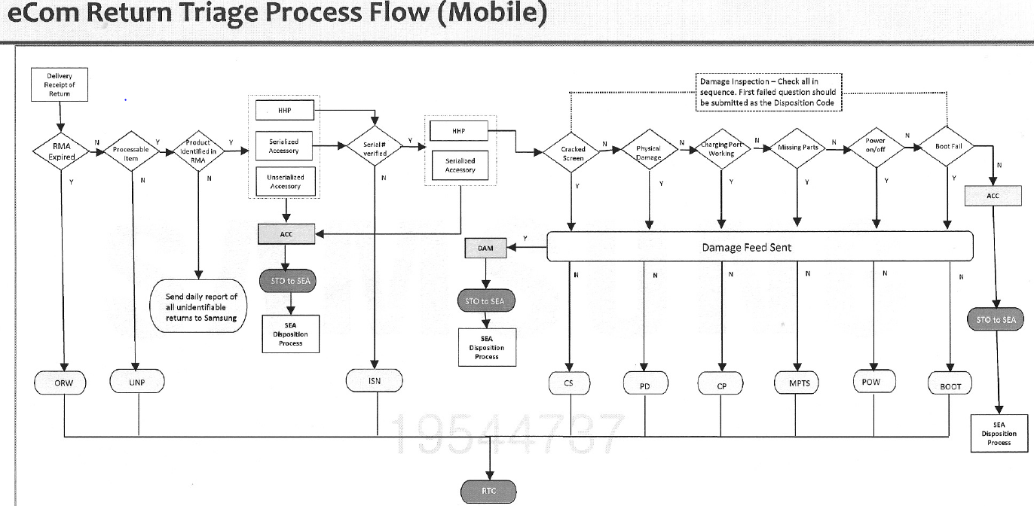
(Fig.2)

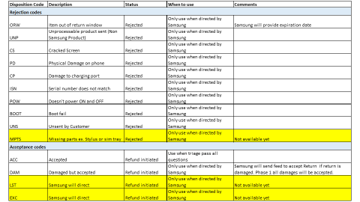

  - 3PL shall receive the Product within 24 hours

  - Putaway
    - If packaging was damaged or seal is broken, a LIP is assigned
      - The material is placed in a box
      - The box is placed on a cart
      - Systematically the material is assigned to a bin location in Aisles 015 -018 (known as the Boneyard)
      - The Stock LIP is made unavailable( Blocked)
    - Received refused product in good condition is assigned a license plate (LIP) and placed on a pallet to be returned to A stock (pick-able location).
      - The product’s LIP and material is scanned to a pre-assigned bin location.
  - Exceptions
    - If item received is outside normal acceptable returns/refusal standards said items are:
      - Added to the exceptions report. (UNS, Miss-ship, Item not on RMA, Ect.) as a tab in the EOD report.
      - The material is physically moved to the Exception Cart
    - UNS (Unsent) - if an item is not sent in with the rest of the return the missing item is systemically processed as UNS. If an item is determined to be UNS, Geodis processes the item as an an OTG adapter which has little financial impact and which closes the RMA.
    - Item Not on RMA. The customer sends in an item that is not on the RMA it is logged on the exceptions report. An Ecom team member confims that the item in question is an S.com order by referencing the customer’s order history If the item is found, a request is sent to the Customer service team for a new RMA. If the item is not found then it it returned to the customer and the Customer service team is notified via email.
    - New RMA needed- this occurs when the processors make an error and omits an item or process an item incorrectly. If an item that is not on the RMA is sent in by the customer a new RMA must be requested. To request a New RMA the Ecomm associate will reach out to the customer service team and provide the needed information.
      - Take the exceptions report filter down to “NEED NEW RMA” and insert a tab, “New RMA”, after the RMA tab (this provides a place for the customer service team to add the new RMA (see figure 3).
(Figure 3)
Date Added | RMA | New RMA | PO ID | SKU | Description of Item | Serial Number | Receipt Date | Tracking # | Exception Reason
7/15/2020 | OJ0E9C8 |  | US502181344 | SM-R175NZKAXAR | Galaxy Buds + | RFAN32ZEPPK |  |  | Need new RMA
7/18/2020 | F1WDZPL |  | US568956119 | SM-G988UZKAXAA | Galaxy S20 Ultra 5G 128GB (Unlocked) | 352574111275986 | 7/6/2020 | 394391404940 | Need new RMA
7/18/2020 | F1WDZPL |  | US568956119 | SM-R175NZBAXAR | Galaxy Buds+, Cloud Blue | RFAN40AJBTM | 7/6/2020 | 394391404940 | Need new RMA

    - Misship- Please see Misship SOP

    - SEA validates the report and works to resolve any issues.

